CloudExify Summer Internship 2026
Data Science — Month 1 (Final)
Project 2
Customer Segmentation Analysis
TrendLine Apparel — RFM & K-Means Customer Segmentation Report
Prepared by: Hafsa Bukhtiar Chishti
COMSATS University Islamabad, Sahiwal Campus
Software Engineering Department
Submission: End of Month 1 — FINAL | July 2026

Table of Contents
Table of Contents
Table of Contents 2
1. Executive Summary 3
2. Introduction 3
3. Project Objectives 3
4. Tools & Technologies 4
5. Methodology Overview 4
6. Dataset Description 5
7. RFM Feature Engineering 5
8. Feature Normalization 5
9. Choosing the Number of Clusters (K) 5
10. Applying K-Means Clustering 6
11. Segment Profiles 7
11.1 Reading the Profile Table 7
12. 3D Visualization of Segments 7
13. Business Recommendations 8
13.1 High-Value Segment 8
13.2 Mid-Value Segment 8
13.3 Low-Value Segment 8
14. Automated Report Generation 9
15. Key Findings 9
15.1 Segment Structure is Genuine, Not Arbitrary 9
15.2 Revenue is Concentrated in a Minority of Customers 9
15.3 The Largest Segment Has the Most Untapped Potential 9
15.4 "Low-Value" Does Not Mean "Low Potential" 10
15.5 Feature Scaling Was Not Optional 10
16. Skills Gained 10
16.1 Feature Engineering 10
16.2 Unsupervised Machine Learning 10
16.3 Cluster Interpretation 10
16.4 3D Visualization 10
16.5 Translating Statistics into Business Action 10
16.6 Structuring a Machine Learning Notebook 11
17. Limitations & Future Work 11
17.1 Synthetic Data 11
17.2 Fixed Reference Date 11
17.3 Algorithm Choice 11
17.4 No Product-Level Detail 11
18. Conclusion 12
19. Appendix A — Key Code Snippets 12
A.1 RFM Computation 12
A.2 Clustering & Segment Naming 12
20. Appendix B — Glossary of Terms 13

1. Executive Summary
This report documents the methodology and findings of Project 2 — Customer Segmentation Analysis — the final deliverable of the CloudExify Data Science Internship (Summer 2026), Month 1. Building on the exploratory data analysis skills practiced in Project 1, this project introduces unsupervised machine learning: grouping customers into meaningful segments using RFM (Recency, Frequency, Monetary) analysis combined with K-Means clustering.
The analysis covers 800 customers of the fictional fashion brand TrendLine Apparel, derived from 6,299 individual transactions recorded between 2024-01-01 and 2026-06-04. Rather than treating every customer identically, this project identifies three distinct behavioral segments — High-Value, Mid-Value, and Low-Value — and proposes a specific marketing action for each.
Beyond the base project requirements, this analysis validates the choice of cluster count using both the Elbow Method and the Silhouette Score, rather than relying on a single visual heuristic, and translates each cluster into a concrete, actionable business recommendation rather than stopping at the statistical grouping alone.

2. Introduction
Project 1 focused on describing what happened in aggregate sales data — which products sold, which months were strongest, which regions performed best. Project 2 shifts the lens from products to people: rather than asking what sold, it asks who is buying, how often, how recently, and how much — and whether customers naturally fall into distinguishable groups based on that behavior.
This is the introductory application of unsupervised machine learning within the CloudExify Data Science track. Unlike Project 1's analysis, there is no pre-existing "correct answer" for how customers should be grouped — K-Means discovers structure directly from the data, and the analyst's job is to choose a sensible number of groups, interpret what each group represents, and translate that into a decision the business can act on.
As with Project 1, the implementation here is original — structured around small, reusable functions (RFM computation and report generation) rather than a single linear script — and extends the base checklist with a silhouette-score cross-check and a written, segment-specific action plan.

3. Project Objectives
- Load transaction-level customer purchase data and engineer RFM (Recency, Frequency, Monetary) features per customer.
- Normalize the RFM features so that no single metric dominates the clustering purely due to its numeric scale.
- Use the Elbow Method to identify a reasonable number of clusters (K).
- Apply K-Means clustering to group customers into segments.
- Profile each segment (average Recency, Frequency, Monetary, and segment size).
- Visualize the segments in 3D RFM space.
- Translate each segment into a specific, actionable business recommendation.
- Generate an automated summary report of the findings.

4. Tools & Technologies
Language | Python 3
Environment | Jupyter Notebook
Data Manipulation | pandas, NumPy
Machine Learning | scikit-learn (StandardScaler, KMeans, silhouette_score)
Visualization | matplotlib (including 3D projection)
Report Output | Plain-text (.txt) automated report

scikit-learn is the key addition compared to Project 1 — specifically its `StandardScaler` for feature normalization, its `KMeans` implementation for clustering, and `silhouette_score` for validating the chosen number of clusters.

5. Methodology Overview
The analysis follows a five-stage pipeline, mirroring the structured approach used in Project 1 but adapted for a machine learning workflow:
- Stage 1 — Load: Read transaction-level data (one row per purchase, many rows per customer).
- Stage 2 — Feature Engineering: Collapse each customer's full transaction history into exactly three numbers — Recency, Frequency, Monetary — via the RFM framework.
- Stage 3 — Normalize: Scale all three features to a comparable range using StandardScaler, since K-Means is distance-based and sensitive to differing scales.
- Stage 4 — Cluster: Choose K using the Elbow Method and Silhouette Score, then fit K-Means and assign each customer to a segment.
- Stage 5 — Interpret & Report: Profile each segment numerically, visualize it in 3D, and translate the statistical grouping into a specific business action.

6. Dataset Description
The dataset used, customer_transactions.csv, contains 6,299 individual purchase transactions made by 800 unique customers of TrendLine Apparel between 2024-01-01 and 2026-06-04.
Column | Description
CustomerID | Unique identifier for each customer
TransactionID | Unique identifier for each individual purchase
Date | Date the transaction occurred
Product | Item purchased
Amount | Value of that specific transaction

Unlike Project 1's dataset, where each row was an independent sales record, this dataset is inherently relational: a single CustomerID can appear anywhere from once to several dozen times, and the entire segmentation analysis depends on correctly aggregating this repeated structure up to the customer level before any modeling begins.

7. RFM Feature Engineering
RFM is a widely used customer-analytics framework built on three simple but powerful signals:
Metric | Business Meaning
Recency | How many days since the customer's most recent purchase — lower is better (more engaged)
Frequency | How many separate purchases the customer has made — higher indicates loyalty
Monetary | Total amount the customer has spent — higher indicates greater value
These three features were computed per customer using a dedicated `compute_rfm()` function, relative to a fixed reference date (2026-06-05), so that Recency reflects a consistent "as of" point in time rather than shifting with whenever the analysis happens to be run.

8. Feature Normalization
Recency is measured in days (ranging into the hundreds), Frequency in purchase counts (typically single or low double digits), and Monetary in rupees (potentially into the hundreds of thousands). K-Means clusters points based on straight-line distance, so without correcting for this, Monetary would completely dominate the clustering simply because its raw numbers are largest — not because it is inherently the most important signal.
`StandardScaler` was applied to rescale all three features to a common range (mean 0, standard deviation 1) before clustering, ensuring Recency, Frequency, and Monetary all contribute proportionally to how customers are grouped.

9. Choosing the Number of Clusters (K)
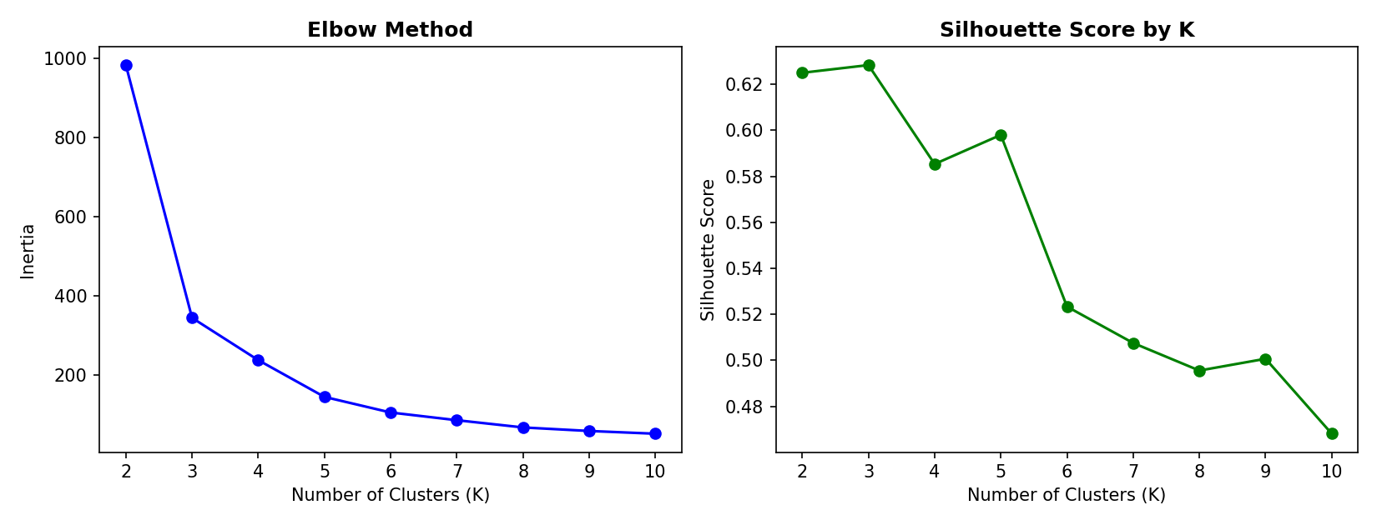
Figure 1 — Elbow Method (left) and Silhouette Score (right) across K = 2 to 10.
Two independent methods were used to choose K, rather than relying on a single visual judgment call:
- The Elbow Method plots inertia (within-cluster spread) against K — the point where additional clusters stop meaningfully reducing spread suggests a reasonable stopping point.
- The Silhouette Score measures how well-separated clusters are, on a scale from -1 to 1, independently of the elbow shape.
In this analysis, the silhouette score was maximized at K = 3, which aligns with the natural, business-interpretable three-way split into Low, Mid, and High-Value segments — giving two independent forms of evidence pointing to the same choice of K = 3.

10. Applying K-Means Clustering
With K = 3 selected, K-Means was fit on the scaled RFM features. Since K-Means assigns arbitrary numeric cluster labels (0, 1, 2) with no inherent business meaning, the clusters were re-labeled by ranking their average Monetary value — the lowest-spending cluster became "Low-Value," the highest-spending became "High-Value," and the remaining cluster became "Mid-Value." This makes the output immediately interpretable to a non-technical reader rather than requiring them to remember which arbitrary number corresponds to which group.

11. Segment Profiles
Segment | Customers | % of Total | Avg Recency (days) | Avg Frequency | Avg Monetary (Rs)
High-Value | 119 | 14.9% | 10.4 | 22 | 134,097
Mid-Value | 408 | 51% | 51.6 | 7.7 | 25,462
Low-Value | 273 | 34.1% | 252.3 | 2 | 3,784

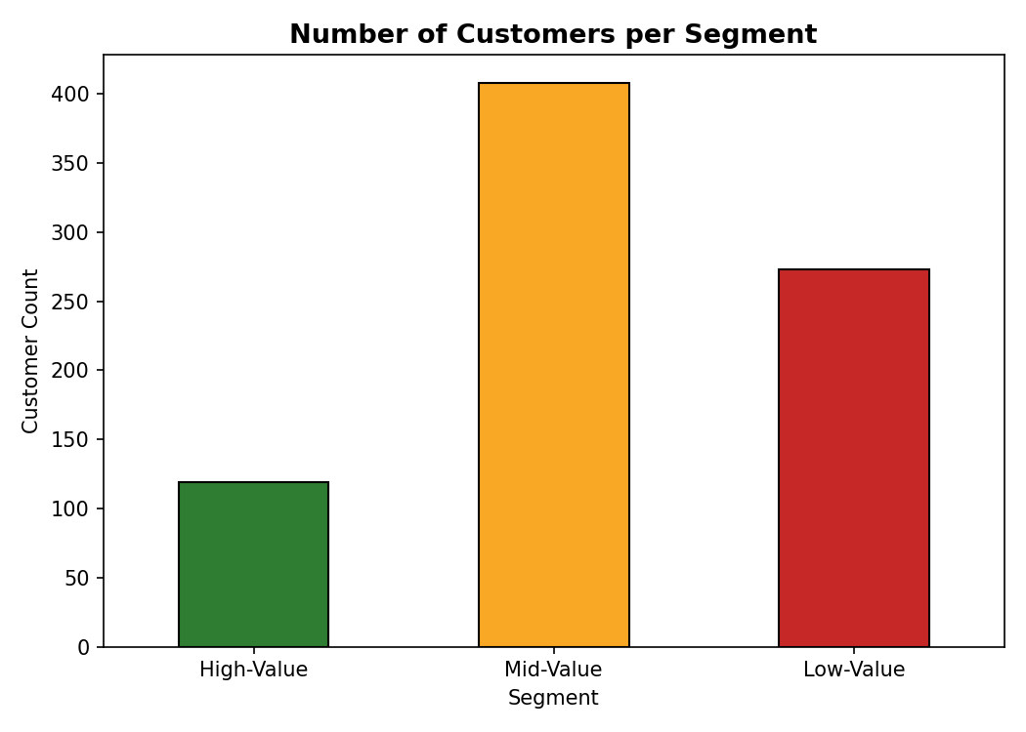
Figure 2 — Number of customers in each segment.
High-Value customers make up only 14.9% of the customer base but average Rs 134,097 in total spend — dramatically more than the Mid or Low-Value groups. Mid-Value is the largest group at 51%, representing the bulk of the customer base with moderate engagement. Low-Value customers, at 34.1%, show an average Recency of over 252 days — more than eight months since their last purchase — suggesting many of them are lapsed customers rather than customers who were never engaged in the first place.

11.1 Reading the Profile Table
The three RFM columns tell a consistent, reinforcing story across all three segments rather than three unrelated numbers. High-Value customers score well on all three dimensions simultaneously — low Recency (10.4 days), high Frequency (22 purchases), and high Monetary value (Rs 134,097) — which is exactly the pattern one would expect from a genuinely engaged, valuable customer. Low-Value customers show the mirror-image pattern: high Recency (252.3 days), low Frequency (2 purchases), and low Monetary value (Rs 3,784). Mid-Value customers sit consistently between the two extremes on every dimension, rather than being strong on one metric and weak on another — this internal consistency is a good sign that the clustering has found a genuine underlying gradient of customer engagement, rather than three arbitrary or contradictory groupings.

12. 3D Visualization of Segments
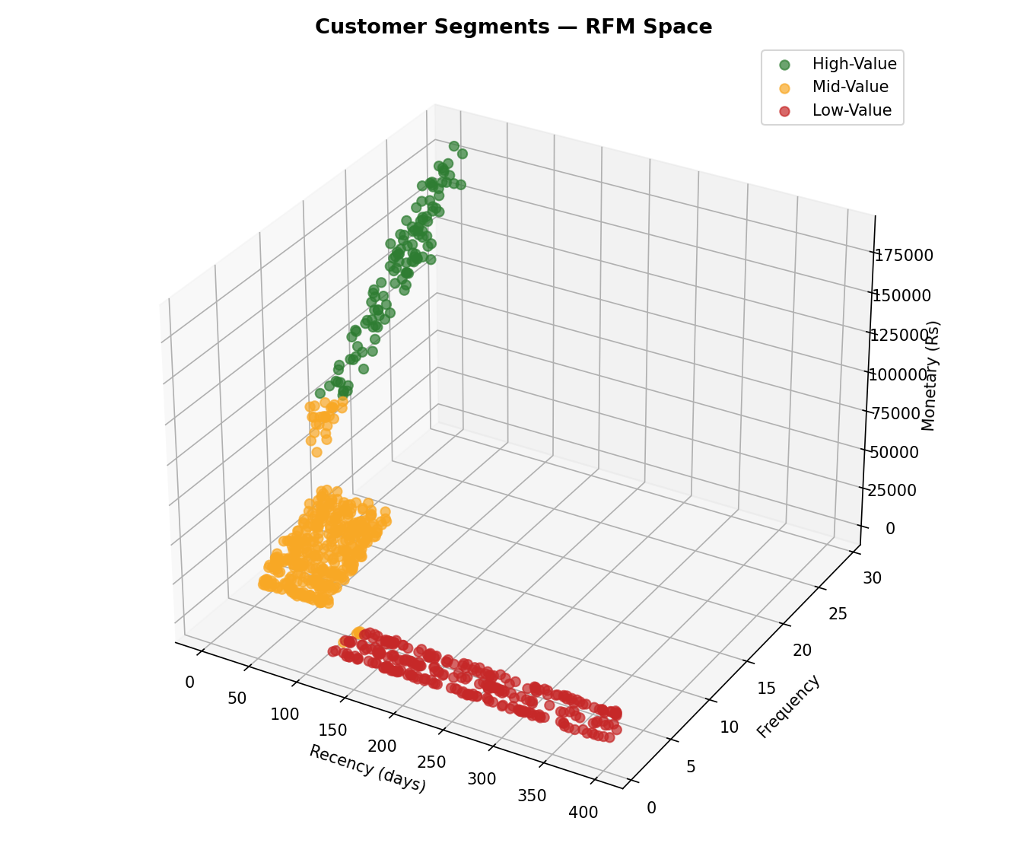
Figure 3 — Customer segments plotted in three-dimensional RFM space.
Plotting all three RFM dimensions simultaneously makes the separation between segments visually intuitive: High-Value customers cluster toward low Recency, high Frequency, and high Monetary; Low-Value customers cluster in the opposite corner of the space; and Mid-Value customers occupy the space between them. The visual separation between the three color-coded groups supports the numerical evidence that K = 3 produces a meaningful, non-arbitrary split.

13. Business Recommendations

13.1 High-Value Segment
These customers already purchase often and recently, and represent the highest average spend by a wide margin. The priority here is retention, not persuasion: early access to new collections, a dedicated support channel, and loyalty rewards are appropriate, since the cost of losing one of these customers is significant relative to the cost of retaining them.

13.2 Mid-Value Segment
This is the largest segment and represents the greatest growth opportunity. Targeted cross-sell campaigns (e.g., bundle offers building on their existing purchase categories) and a structured loyalty program could plausibly move a meaningful share of this group toward High-Value behavior over time.

13.3 Low-Value Segment
The defining characteristic of this segment is high Recency, not low historical spend — many of these customers have simply drifted away rather than never having been engaged. This distinction matters operationally: a blanket discount strategy risks training already-engaged customers to wait for discounts, whereas a time-limited win-back campaign specifically targeted at this segment is more likely to re-activate genuinely lapsed customers without discounting unnecessarily elsewhere.

14. Automated Report Generation
As with Project 1, a dedicated `generate_segmentation_report()` function recomputes every figure directly from the clustered data and writes a formatted summary to `segmentation_report.txt`. This includes segment sizes and percentages, average Recency/Frequency/Monetary per segment, and the full text of each segment's recommendation — ensuring the report can never drift out of sync with the underlying clustering results if the input data changes.

15. Key Findings
This section consolidates the statistical results from Sections 9 through 13 into a small set of business-relevant takeaways.

15.1 Segment Structure is Genuine, Not Arbitrary
A clear three-segment structure emerged directly from customer purchase behavior, with both the Elbow Method and Silhouette Score independently supporting K = 3. This dual-metric agreement matters: relying on a single visual heuristic (the elbow chart alone) can sometimes be ambiguous, especially when the "elbow" in the chart is gradual rather than sharp. Having the silhouette score point to the same value independently gives considerably more confidence that three segments reflect real structure in customer behavior, rather than an arbitrary cut chosen for convenience.

15.2 Revenue is Concentrated in a Minority of Customers
High-Value customers make up only 14.9% of the customer base but generate disproportionate revenue relative to their share of the customer count — their average spend of Rs 134,097 dwarfs both other segments. This is a classic and well-documented retail pattern, often summarized as a Pareto-style distribution, where a small fraction of customers account for an outsized share of total value. Retention effort directed at this segment is therefore especially high-leverage: losing even a handful of these customers represents a meaningfully larger revenue impact than losing an equivalent number of Low-Value customers.

15.3 The Largest Segment Has the Most Untapped Potential
Mid-Value customers (51%) form the largest segment and, by virtue of their size alone, represent the greatest absolute opportunity for growth-oriented marketing. Unlike High-Value customers (who may already be close to their natural spending ceiling) or Low-Value customers (many of whom may be disengaged), Mid-Value customers have demonstrated real purchase intent and loyalty, but with room to grow in both frequency and basket size.

15.4 "Low-Value" Does Not Mean "Low Potential"
Low-Value customers (34.1%) are characterized primarily by long Recency (over 252 days on average) rather than inherently low spending capacity — their historical average spend of Rs 3,784 shows they were willing to purchase at some point. This distinction should directly shape the recommended intervention: a win-back campaign aimed at re-engaging lapsed customers is a fundamentally different (and likely more effective) strategy than assuming these customers were simply never interested.

15.5 Feature Scaling Was Not Optional
Feature scaling (StandardScaler) was essential to producing a meaningful clustering result — without it, Monetary's naturally larger numeric range (potentially in the hundreds of thousands, versus Frequency's typically single or double digits) would have dominated the distance calculations that K-Means relies on, effectively clustering customers on spend alone while ignoring how recently or how often they purchase.

16. Skills Gained

16.1 Feature Engineering
Practical experience collapsing repeated, transaction-level records into a single meaningful feature vector per entity (per customer) — a pattern that generalizes well beyond RFM to many other customer- or entity-level analyses, such as summarizing website visit logs into per-user engagement metrics, or summarizing patient visit histories into per-patient health indicators.

16.2 Unsupervised Machine Learning
First hands-on application of K-Means clustering, including the practical necessity of feature scaling before distance-based algorithms, and the process of choosing K using more than one piece of evidence rather than a single chart read in isolation.

16.3 Cluster Interpretation
Learning that a clustering algorithm's numeric output (0, 1, 2) is not inherently meaningful — it must be actively interpreted and mapped to business-relevant labels (Low/Mid/High-Value) based on the actual characteristics of each group, in this case by ranking clusters by their average Monetary value rather than trusting the arbitrary label order K-Means assigns internally.

16.4 3D Visualization
Building and interpreting a three-dimensional scatter plot using matplotlib's `mplot3d` toolkit, to communicate multi-dimensional clustering results in a single, intuitive figure rather than requiring the reader to mentally combine three separate 2D charts.

16.5 Translating Statistics into Business Action
Perhaps the most transferable skill practiced in this project was the final step: taking a purely statistical output (three numeric clusters) and translating it into three distinct, specific, and actionable marketing recommendations. A clustering result on its own has limited business value until someone connects each group's numeric profile to a concrete decision — this project practiced making that connection explicitly rather than leaving it implicit.

16.6 Structuring a Machine Learning Notebook
As with Project 1, the analysis was organized as a small number of named, reusable functions — compute_rfm() and generate_segmentation_report() — rather than one long script, making the underlying logic easier to read, easier to test independently, and easier to re-apply to a different customer transaction dataset with the same structure.

17. Limitations & Future Work
A few limitations of this analysis are worth stating plainly, both for transparency and as a guide to what a follow-on iteration could improve:

17.1 Synthetic Data
As with Project 1, the customer transaction data was generated programmatically, with three latent behavior archetypes (champion, regular, dormant) deliberately built into the random generation process. This means the clean, well-separated segments found here are, to some extent, a product of how the data was constructed rather than purely an emergent discovery. The methodology itself — RFM computation, scaling, clustering, and profiling — is nonetheless directly applicable to real transaction data with the same CustomerID/Date/Amount structure, and would be expected to produce messier, less cleanly separated clusters on genuine, noisier real-world data.

17.2 Fixed Reference Date
Recency was computed relative to a single fixed reference date (2026-06-05). In a live production setting, this would typically need to be refreshed regularly — for example, recalculated weekly or monthly — as new transactions arrive, since a customer's Recency (and therefore their segment) can change simply due to the passage of time, even without any change in their underlying purchasing behavior.

17.3 Algorithm Choice
K-Means assumes clusters are roughly spherical and similarly sized in the scaled feature space. A real customer base might have more irregular, unevenly sized, or overlapping groupings that a different algorithm — such as DBSCAN (which does not assume spherical clusters) or hierarchical clustering (which does not require K to be chosen in advance) — could capture more faithfully. Comparing K-Means results against one of these alternative approaches would be a natural robustness check for a future iteration.

17.4 No Product-Level Detail
This analysis segments customers purely on RFM — how recently, how often, and how much they spend — without considering what they actually buy. A natural extension would incorporate category preferences (for example, distinguishing "Footwear-focused High-Value customers" from "Accessories-focused High-Value customers"), which would allow marketing recommendations to be tailored not just by value tier but by product interest as well.

18. Conclusion
Project 2 successfully met the requirements of the CloudExify Month 1 Project 2 guide: RFM features were engineered from raw transaction data, normalized appropriately, and clustered using K-Means with a defensible, dual-metric choice of K. The resulting three segments were profiled, visualized in 3D, and translated into concrete business recommendations rather than left as an abstract statistical output. Together with Project 1, this completes the full Month 1 Data Science track — from descriptive analysis of aggregate sales data to unsupervised customer segmentation.

19. Appendix A — Key Code Snippets

A.1 RFM Computation
def compute_rfm(df: pd.DataFrame, reference_date: pd.Timestamp) -> pd.DataFrame:
rfm = df.groupby('CustomerID').agg(
Recency=('Date', lambda x: (reference_date - x.max()).days),
Frequency=('TransactionID', 'count'),
Monetary=('Amount', 'sum'),
)
return rfm

A.2 Clustering & Segment Naming
scaler = StandardScaler()
rfm_scaled = scaler.fit_transform(rfm[['Recency','Frequency','Monetary']])

kmeans = KMeans(n_clusters=3, random_state=42, n_init=10)
rfm['Cluster'] = kmeans.fit_predict(rfm_scaled)

# Rank clusters by avg Monetary value, map to business-friendly names
cluster_order = rfm.groupby('Cluster')['Monetary'].mean() \
.sort_values().index.tolist()
segment_names = {cluster_order[0]: 'Low-Value',
cluster_order[1]: 'Mid-Value',
cluster_order[-1]: 'High-Value'}
rfm['Segment'] = rfm['Cluster'].map(segment_names)
The full, executable implementation — including the elbow/silhouette evaluation and 3D visualization code referenced above — is available in the accompanying notebook, customer_segmentation.ipynb.

20. Appendix B — Glossary of Terms
Term | Definition
RFM | Recency, Frequency, Monetary — a customer-analytics framework summarizing purchase behavior in three numbers.
K-Means | An unsupervised machine learning algorithm that groups data points into K clusters based on distance to each cluster's center.
StandardScaler | A preprocessing tool that rescales features to have mean 0 and standard deviation 1, so features on different scales contribute equally to distance-based algorithms.
Inertia | The sum of squared distances between each point and its assigned cluster center; used in the Elbow Method.
Silhouette Score | A metric (-1 to 1) measuring how well-separated and well-matched clusters are; higher is better.
Segment | A named, business-interpretable group of customers derived from a numeric cluster.
Recency | Days since a customer's most recent purchase.
Churn / Lapsed Customer | A customer who has stopped purchasing, typically identified by unusually high Recency.

